***Types of Regression Analysis***

There are numerous regression analysis approaches available for making predictions. Additionally, the choice of technique is determined by various parameters, including the number of independent variables, the form of the regression line, and the type of dependent variable.

**Let us examine several of the most often utilized regression analysis techniques:**

**1. Linear Regression**

The most extensively used modelling technique is linear regression, which assumes a linear connection between a dependent variable (Y) and an independent variable (X). It employs a regression line, also known as a best-fit line. The linear connection is defined as Y = c+m*X + e, where ‘c’ denotes the intercept, ‘m’ denotes the slope of the line, and ‘e’ is the error term.

The linear regression model can be simple (with only one dependent and one independent variable) or complex (with numerous dependent and independent variables) (with one dependent variable and more than one independent variable).

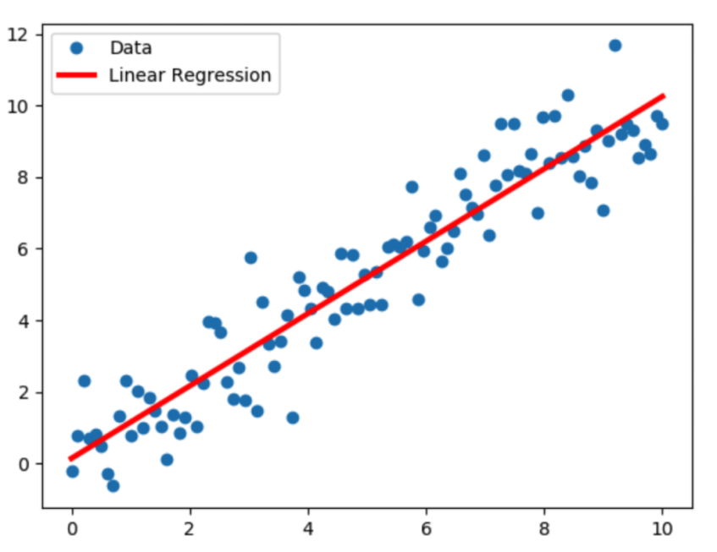

**2. Logistic Regression**

When the dependent variable is discrete, the logistic regression technique is applicable. In other words, this technique is used to compute the probability of mutually exclusive occurrences such as pass/fail, true/false, 0/1, and so forth. Thus, the target variable can take on only one of two values, and a sigmoid curve represents its connection to the independent variable, and probability has a value between 0 and 1.

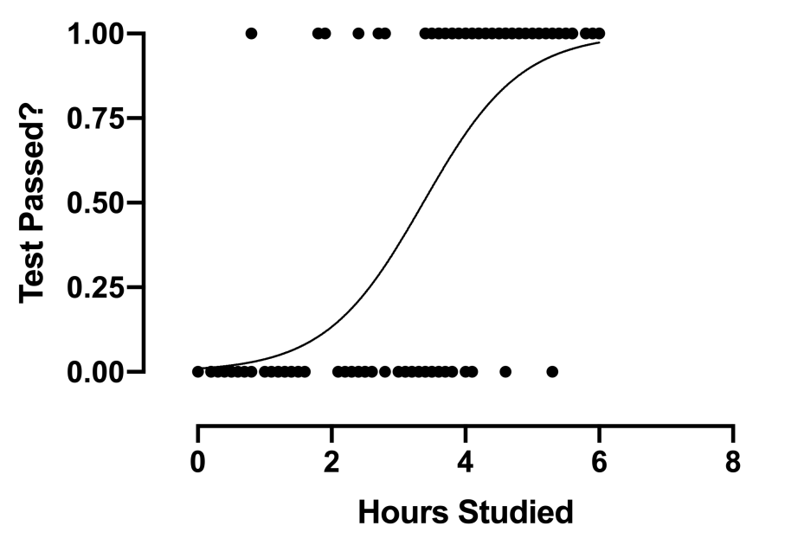

**3. Polynomial Regression**

The technique of polynomial regression analysis is used to represent a non-linear relationship between dependent and independent variables. It is a variant of the multiple linear regression model, except that the best fit line is curved rather than straight.

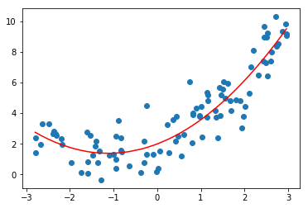

**4. Ridge Regression**

When data exhibits multicollinearity, that is, the ridge regression technique is applied when the independent variables are highly correlated. While least squares estimates are unbiased in multicollinearity, their variances are significant enough to cause the observed value to diverge from the actual value. Ridge regression reduces standard errors by biassing the regression estimates.

The lambda (λ) variable in the ridge regression equation resolves the multicollinearity problem.

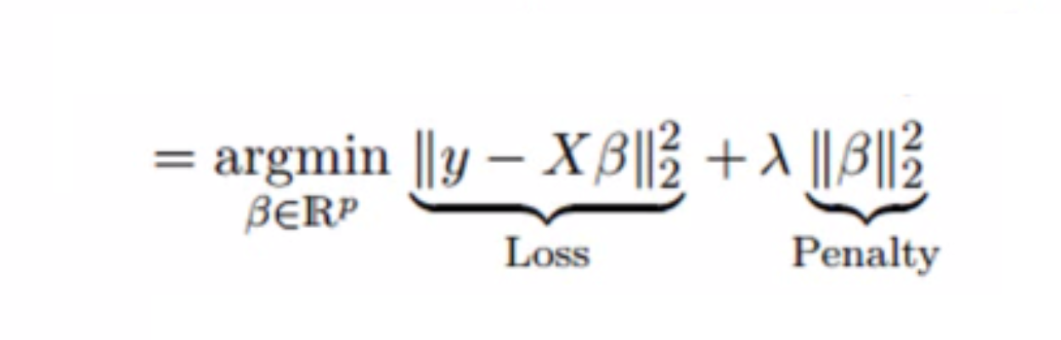

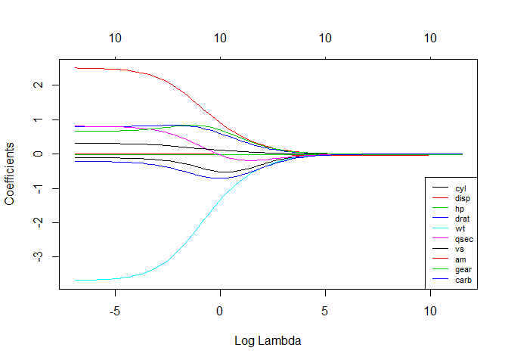

**5. Lasso Regression**

As with ridge regression, the lasso (Least Absolute Shrinkage and Selection Operator) technique penalizes the absolute magnitude of the regression coefficient. Additionally, the lasso regression technique employs variable selection, which leads to the shrinkage of coefficient values to absolute zero.

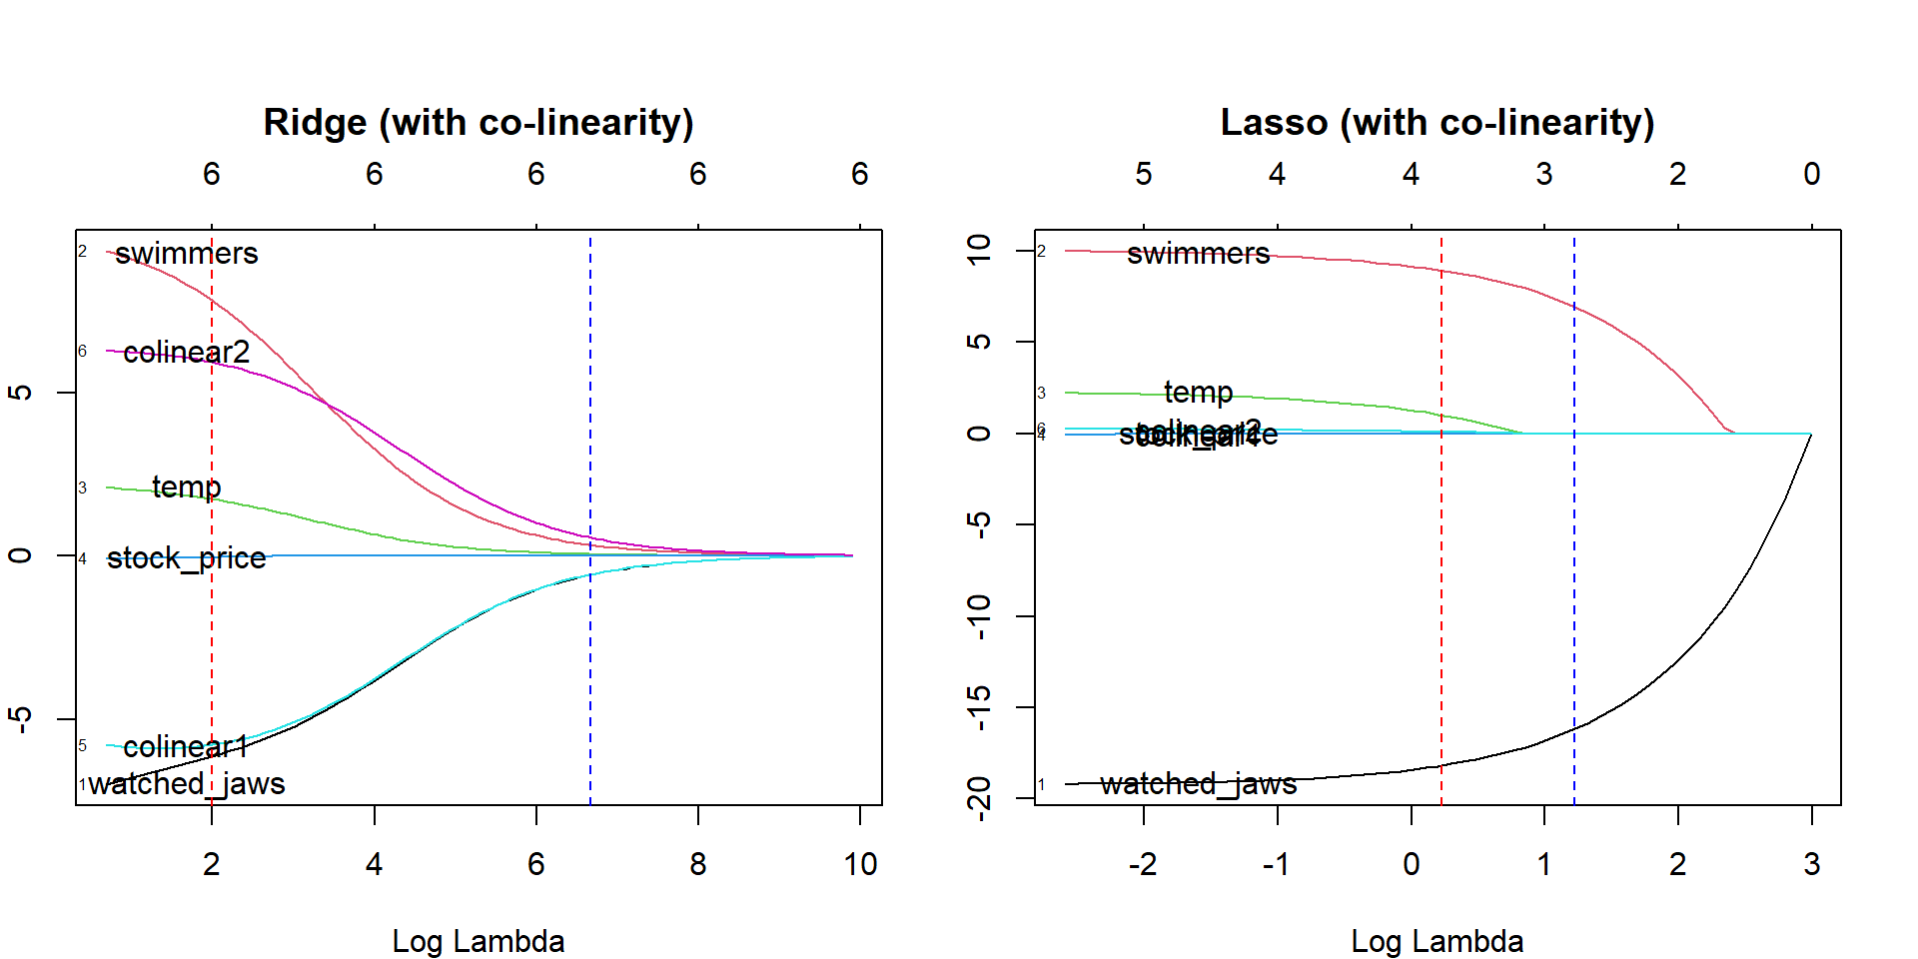

**6. Quantile Regression**

The quantile regression approach is a subset of the linear regression technique. It is employed when the linear regression requirements are not met or when the data contains outliers. In statistics and econometrics, quantile regression is used.

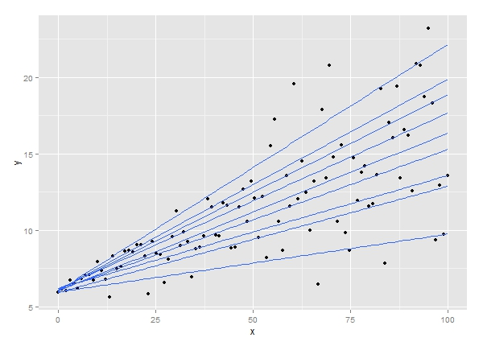

**7. Bayesian Linear Regression**

Bayesian linear regression is a form of regression analysis technique used in machine learning that uses Bayes’ theorem to calculate the regression coefficients’ values. Rather than determining the least-squares, this technique determines the features’ posterior distribution. As a result, the approach outperforms ordinary linear regression in terms of stability.

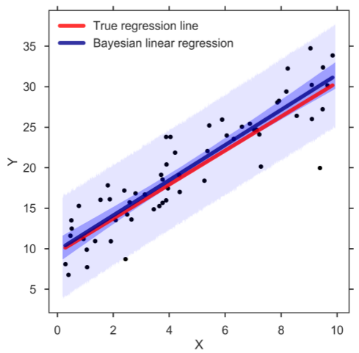

**8. Principal Components Regression**

Multicollinear regression data is often evaluated using the principle components regression approach. The significant components regression approach, like ridge regression, reduces standard errors by biassing the regression estimates. Principal component analysis (PCA) is used first to modify the training data, and then the resulting transformed samples are used to train the regressors.

**9. Partial Least Squares Regression**

The partial least squares regression technique is a fast and efficient covariance-based regression analysis technique. It is advantageous for regression problems with many independent variables with a high probability of multicollinearity between the variables. The method decreases the number of variables to a manageable number of predictors, then is utilized in a regression.

**10. Elastic Net Regression**

Elastic net regression combines ridge and lasso regression techniques that are particularly useful when dealing with strongly correlated data. It regularizes regression models by utilizing the penalties associated with the ridge and lasso regression methods.

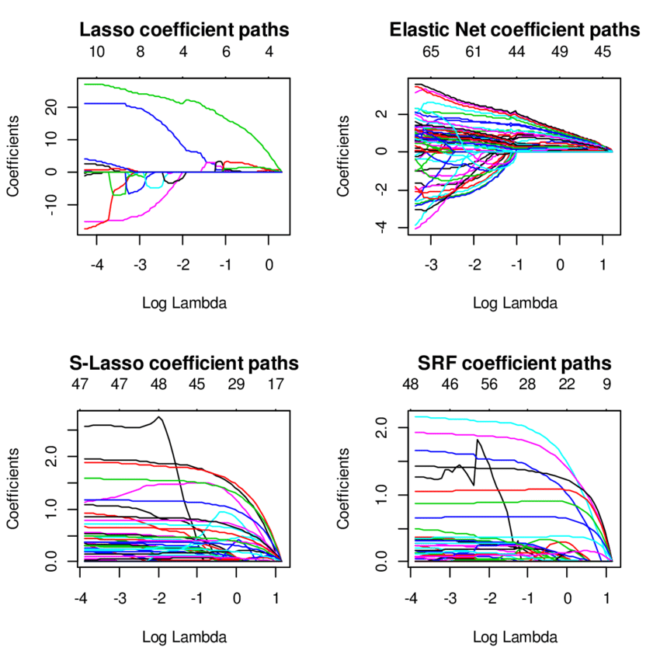

**Summary**

Machine learning employs a variety of other regression models, such as ecological regression, stepwise regression, jackknife regression, and robust regression, in addition to the ones discussed above. For each of these various regression techniques, know how much precision may be gained from the provided data. In general, regression analysis provides two significant advantages, and these include the following:

* It denotes the relationship between two variables, one dependent and one independent.
* It demonstrates the magnitude of an independent variable’s effect on a dependent variable.